26. Client library in AEM

**What?**

To manage client side resources (js, css, images etc).

**Why?**

To keep all the client side resources organized in project folders in the CRX repository.

As site pages grows bigger, clientlibs maintains the client side resources in a better way when compared to the traditional way of including the JS, CSS and other files.

**Calling client library**

**Calling JS files alone**



**Calling CSS files alone**



**Loading all clientlibs**



**Useful properties**

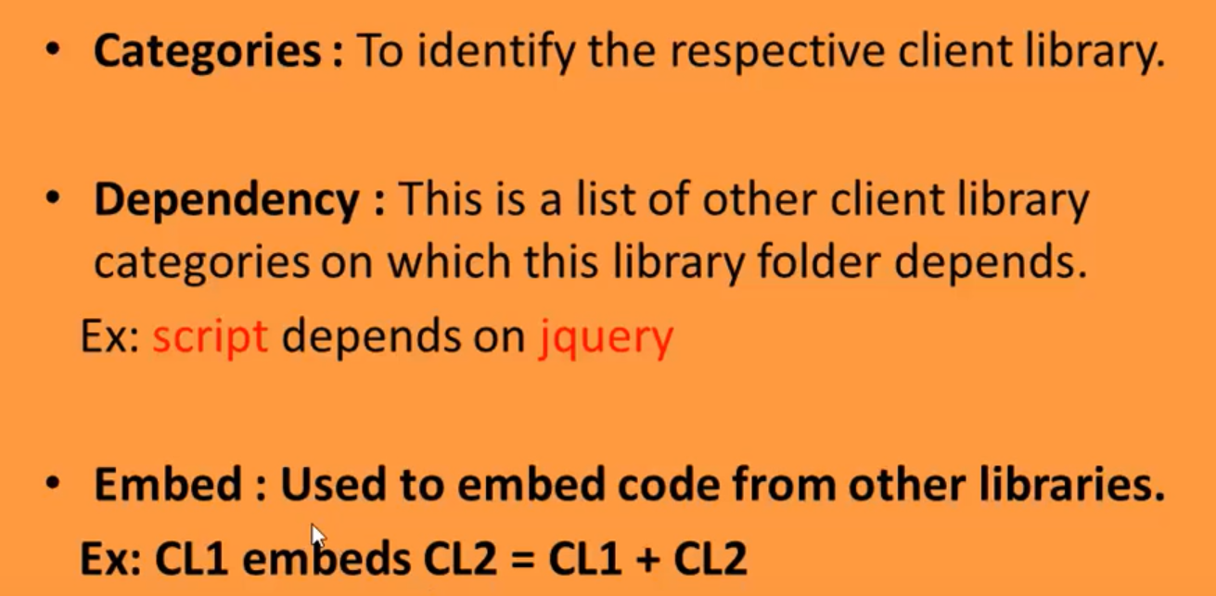

## Useful Resources :

**Diff b/w embed and dependencies**